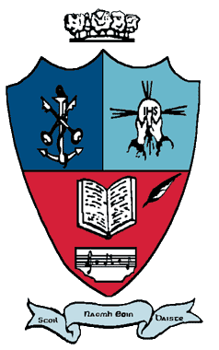 Please note the holiday arrangements for the year 2016/2017.

School Re-opening: Wednesday 31st August 2016.

October 2016 mid-term break:

Closed Monday 31st October to Friday 4th November (inclusive).

Christmas 2016:

Close Thursday 22nd December 2016 at 12 noon.

Re-open on Monday 9th January 2017.

February 2017 mid-term break:

Closed Thursday 23rd February 2017 and Friday 24th February 2017.

St. Patrick’s Bank Holiday:

Closed Friday 17th March, Monday 20th March and Tuesday 21st March 2017.

Easter 2017:

Close on Friday 7th April 2017 at 12 noon*.

Re-open on Monday 24th April 2017.

* Where contingency arrangements are required to make up for time lost due to unforeseen closures,
the school authority may reduce the length of the Easter break by remaining open up to and including
Wednesday 12th April 2017, as per Department of Education circular 0034/2011.

May Bank Holiday:

Closed Monday 1st May 2017.

June Bank Holiday:

Closed Friday 2nd June, Monday 5th June and Tuesday 6th June 2017.

Summer Holidays: Close Friday 30th June 2017 at 12 noon.

